Good Fences Make Good Neighbours: The False 45th
and Our International Border
An Imaginary Line
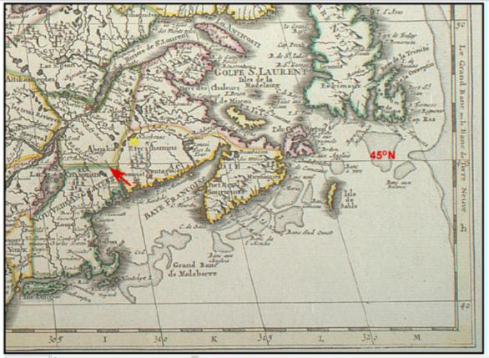
What is so special about the 45th line of north latitude? Blame the Age of Enlightenment, perhaps even blame the Dutch! The Canada - U.S. border is a strangely arbitrary affair. It cuts across the very grain of our countryside in the Eastern Townships and the Northeast Kingdom, perversely defying a landscape far more predisposed to follow its geological foundations, now expressed by lakes, rivers and mountain ranges, all of which dutifully trend north-south. In ancient times, the division of territories between tribes and kingdoms respected these natural scars carved into the landscape by primordial forces, but in the 16th century as reason slowly superseded faith and inertia, certain intellectuals of the day sought to impose a degree of mathematical and geographical order to our chaotic world. The concept of applying an imaginary grid upon this terrestrial sphere dates back to Claudius Ptolomaeus or Ptolemy (90 to160 AD), a Roman citizen of Greek descent living in Alexandria, Egypt. He decided to dissect our globe by two suites of conceptual planes, whose intersection on Earth’s surface have become our lines of latitude (or parallels), and longitude (or meridians) that adorn our modern maps. Conceptually ahead of its time, Ptolemy’s grid had little practical importance for another 13 centuries.

Portion of map drawn by the French cartographer Guillaume De L’Isle in 1703 showing the boundary between Canada and New England coincident with 45ºN
It was in the Enlightenment when explorations begat both power and wealth, that sovereign-states became increasingly interested in a scientifically measured world. In particular, this grew out of the commercial opportunities offered by trans-oceanic trade and the acquisition of resource-rich new territory. The former required navigation of the successful and repeatable kind, and the latter needed (arguably) precise and comprehensible boundaries, ones that might limit competitors’ claims. Useful maps and charts were what were needed, and geographers/cosmographers such Gerhard Mercator (1512-1594), produced the technologies to meet this need (i.e. rhumb lines, the Mercator projection, better astrolabes and quadrants).
It turned out that the calculation of latitude by astronomical observation was a relatively straight forward affair well known to the ancient Greeks and Phoenicians. Quite accurate latitude determinations at sea were even possible by the 15th century with instruments such as the geometric quadrant. Longitude was a far more difficult endeavor, and this nut wasn’t cracked until the 1760’s (see reference). As a consequence and for some time, east-west boundaries on land titles, grants, and maps could be expressed as a line of latitude, but the north-south bounds had to be expressed by some geographical phenomenon (e.g. a rivers course), or perhaps a set distance inland from the coast.
The 45th Line of Latitude in North America
In 1606, the Plymouth Company of England received from King James I a charter allowing the company to form settlements from 41º to 45º N Latitude, and subsequent use by the English of this specific northern limit can all be traced back to the 1606 charter. The Dutch in 1614, in claiming the territory to be called New Netherland, decreed its northern boundary to be the 45th parallel. French territorial claims of the period based on the coastal explorations of Champlain and Sieur de Monts (1604-05) extended from 40º to 46º north, so even at this very early moment the stage was set for future conflict between England and France.
Somewhat surprisingly by around 1700 English and French maps would seem to indicate a developing consensus regarding the boundary between New France and New England around the 45th parallel, and there were even preliminary talks between the two crowns to investigate a mutually-agreeable boundary. It came to naught.
As the French subsequently gained commercial ascendancy and control of the interior of the continent, any consensus about boundaries evaporated.
When the English triumphed militarily in 1760, maps once again used the 45º N latitude as an arbitrary division line separating the old provinces of New York and New Hampshire from the newly created province of Quebec, and this boundary was formally entrenched by the Royal Proclamation of October 7th, 1763.
Demarcation on the Ground
Delimiting the 45º latitude boundary between British colonial provinces was a relatively straight forward affair, but marking its path on the ground, proved far more challenging. But what drove the need to actually survey and blaze the agreed upon division line? The simple answer is, greed!
The occupation of Montreal in 1760, and the negotiated peace in 1763 (Treaty of Paris), unleashed in the English colonies an epidemic of land fever. In truth there was a need to open up new lands for agricultural settlement, as the long war years had prevented any western or northern expansion of the colonial frontiers and the population had significantly grown. However this need was limited in scope, and quite secondary to the profit motive. In colonial times the opportunity for making a quick buck were few, but land grants and the speculation therein, were viewed as a legitimate means of dramatically altering one’s financial situation. The making of land grants was, ultimately, the purview of the colonies’ governors and their executive councils. Between the governments of New Hampshire and New York, an avalanche of competing and overlapping grants and land titles literally flew out of their respective council chambers in the period 1749 to 1770.
The problem of overlapping (or even under-lapping) land grants was a continual nuisance, even within a single unchallenged jurisdiction. Confusion and inadequate surveying reigned. Wisely, Governor Moore of New York decided not to hinder his land granting business along his northern border with potential squabbles with his Majesty’s new province of Quebec, and the only practical way to do this was to mark the division line right on the ground where no prospective or actual settler could misinterpret the boundary.
OK, but where is the 45th Parallel?
Although the determination of latitude within a degree or two was well within the skill level of most seaman conversant with the use of a quadrant, a truly accurate fix required more elevated mathematical skills and precision instruments. Assuming even a single point on the imaginary line could be accurately fixed on the ground, then the use of good, magnetic compass survey instruments corrected for declination, would be sufficient to carry a line due east or west from that point.
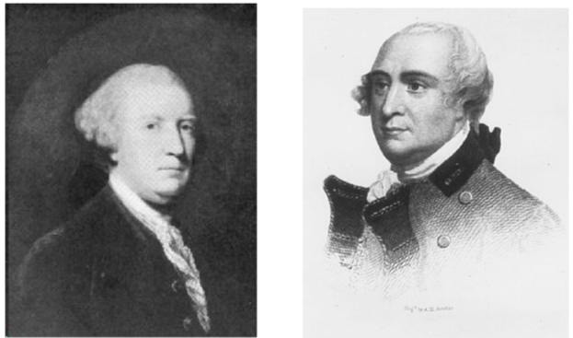
In August of 1766 Sir Henry Moore, Governor of His Majesty’s Province of New York, wrote to Governor Murray of Quebec, proposing that the two provinces fix the 45th line of latitude where it crosses the Richelieu (or Sorrel) River. In Murray’s absence, Lt-Governor Carleton agreed to this proposal, although from the start the Quebec government was the less enthusiastic partner in the enterprise. “ tho’ we did not look upon our interests in that Business to be near so large as theirs ..”. That being said, from 1771 to 1774 Quebec was to assume the lion’s share of the leadership and logistics of surveying the line.
Left. Sir Henry Moore, Right. Lt-Governor Guy Carleton
In 1766 the process of fixing a single point took some 6 weeks of Moore’s time. Moore and Carleton each brought “learned” men to conduct the necessary astronomical observations. On New York’s behalf there was Robert Harpur, a professor of Mathematics at King’s College (later Columbia University, NY). For Quebec it was the experienced surveyor (and Deputy-Surveyor General of Quebec), John Collins. The two experts worked independently, and with their own instruments, and each came to their own determination. Their answers were very different, indeed the two fixes were 6 miles from each other on the east side of Lake Champlain, and in hindsight neither was very close to the truth (although Collins was only 0.75 miles off). Ironically both men made their respective provinces smaller. In the end it was decided that the Quebec instrument was the more accurate and Collin’s fix was somewhat arbitrarily chosen as the 45th.
On August 12th 1768, the Privy Council in London formally approved this determination of the line and ordered the line to be extended eastward towards the headwaters of the Connecticut River.

The Collins – Vallentine Survey
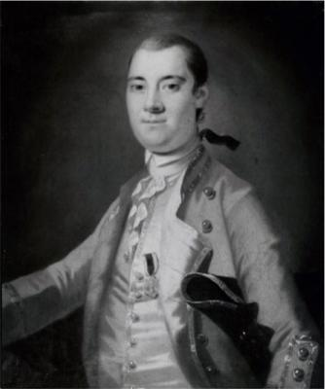
Governor Moore died in 1769 and the impetus for further work apparently flagged. In February of 1771 the new governor of New York, William Tyron resurrected the enterprise, and asked his General Assembly to vote funds to run the line from Lake Champlain to the Connecticut River, with the assumption that Quebec would pick up one half of the total expenses. The Assembly concurred and in May they agreed to underwrite the cost of one half the cost of the survey, as long as it did not exceed 100 pounds (NY currency). When the dust finally settled some four years later, the cost of the complete survey topped 700 pounds.
Governor William Tyron of New York resurrected the survey of the 45th Parallel.

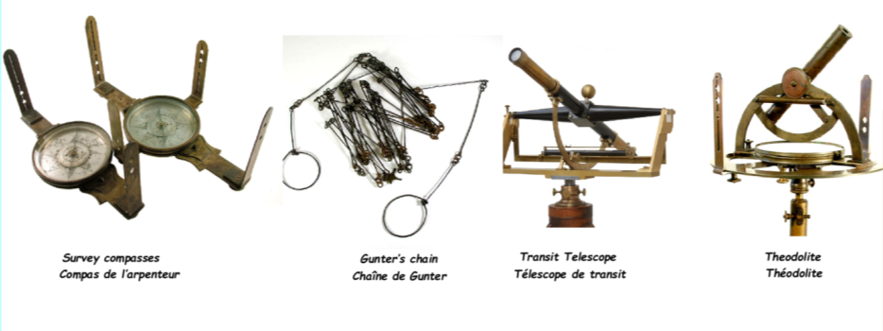
Various survey instruments in use in 2nd half of 18th century
The complete survey, that is eastward from Lake Champlain to the headwaters of the Connecticut River, and then westward from Lake Champlain to the south side of the St. Lawrence River, was accomplished in four stages, and took place between August 1771 to August in 1774. The only consistent player was John Collins from Quebec. The American surveyors and senior representatives, were either reticent, and bailed as soon as opportunity permitted, or were unhealthy. The following men successively filled the post, Adolphus Benzel, Joseph Smith, Thomas Vallentine, and Joseph Saultier. For the final stage, no American was available at all, and Collins finished the job for the benefit of both governments. Of the Americans, Vallentine covered the most ground with Collins, and was part of the team that crossed the Lake Memphremagog region in 1772.

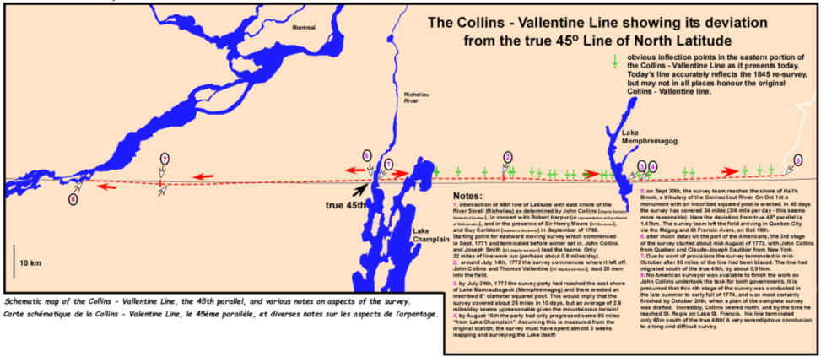
The 20-person joint survey team in 1772 consisted of Collins and Vallentine plus “ 8 (men) to carry Provisions, 4 to cut down such trees as happen to stand in the Line, 2 Blazing the trees that is to say one on each side of the Line, 2 Chainmen, 1 Man to carry Pickets, & 3 Men to carry Our Instruments and Baggage”.
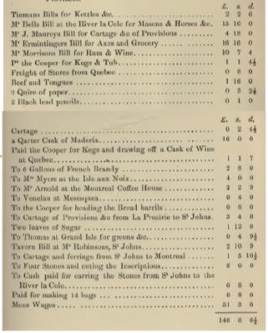
The strongest men on the crew were typically the chainmen, as they were required to pull taught, the 2 pole (or 33 foot) Gunter chain used to measure distance. Any slack in the chain would result in an overestimation of distance.
Partial list of survey expenses submitted by Vallentine and Collins. Note alcohol!
Their mandate included the following instructions, “....... in running said line care must be taken to blaze the Trees on the East and west Sides as you pass along Cutting down only such Trees as stand directly in the sight of the Compass, and at the Distance of every three miles laying together a large Heap of Stones, and cutting a few knotches on the Trees nighest each pile of Stones”. At more significant points, somewhat larger monuments, including inscribed square timber posts were to be erected. Such a post was erected on the east shore of Lake Memphremagog (Ogden) on July 24th, 1772.
Ulterior motives and local opposition
In the 21st century we have, at least on paper, strict conflict-of-interest guidelines for those working for government. In the 18th century, the distinction between what was done for the public good, and what was done for personal gain, was extremely fuzzy. Surveyors were often in an ideal position to play both hands at the same time, and many (perhaps most) did. Nonetheless any open avarice was viewed as indiscreet and so official correspondence rarely alludes to it. Our evidence is somewhat oblique but quite compelling.
- Vallentine, in writing to his boss, the Surveyor-General of New York Alexander Colden on the 7th March, 1772 from LaColle, Quebec, makes it clear that he was active in the land speculation business. “…… there appears so many difficulties in the way that I fear it will be almost impossible to give you any intelligence from the time we enter the woods till we leave them. I shall also beg leave to put you in mind of some little Concerns which I have in Lands, and make no doubt but you will suffer them to go forward as soon any Lands in their Situation are Patented by others. “
- The survey team arrived at the shores of Lake Memphremagog around July 24th. They had barely left this region by August 16th. What were they up to for almost 3 weeks, as clearly they were not making progress on the line itself? Although it is tempting to say they were taking their summer (construction) holidays in what is admittedly a beautiful part of the world, this seems an unlikely answer! In fact, although it formed no part of their official mandate, they were making a detailed map of Lake Memphremagog and the Magog River for the benefit of land speculators. A good number of hunters and other wilderness travellers (including John Stark and Robert Rogers) had passed through this region and commented on its beauty and potential for settlement. I would speculate that either Vallentine or Collins (or both) had been approached prior to starting the survey of the line, with a proposition that both men must have accepted.
- On August 16th, Vallentine writes the following, “Having Occasion to send a man to Montreal I take that opportunity of informing you that we have continued the Line to the Eastward of Lake Mamraabagack and are now about Fifty six miles from Lake Champlain.” The occasion for sending a man to Montreal may have been, I suspect, communication with colleagues concerning the viability of land in the Memphremagog region.
- The survey reached Hall’s Stream on September 30th, 1772 and the survey team returned to Quebec City via the St. Francis River, arriving on October 18th. On November 14th 1772, the first of four coordinated petitions for huge tracts of adjoining land in the Lake Memphremagog region arrived at the Land Committee office in Quebec, accompanied by a detailed map of Lake Memphremagog, identical to (but more complete than) the rendering of the Lake on Collin’s manuscript Division Line survey map. American residents in Quebec, misters Jennison, Jackson, Monroe, and Flannigan, submitted the petitions. Ultimately these petitions were turned down, but it would be very interesting to know what Collins and/or Vallentine received in payment or in future considerations, for their survey of the Lake.

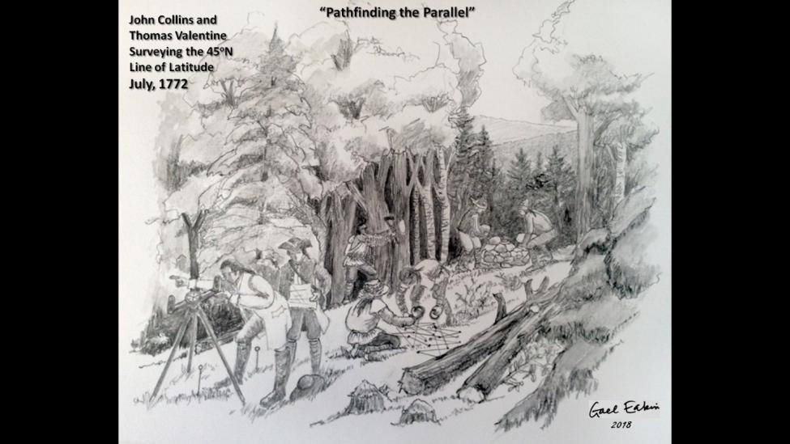
In the 1770’s the Lake Memphremagog region was not an uninhabited wilderness. Seasonally it was a significant hunting and fishing territory of many extended family groups of St. Francis Indians. Not at all surprisingly the local abenakis perceived the survey line and its monuments as both absurd, and highly threatening. Only white men would blaze a useless, dead straight trail across the wilderness guided by a brass-encased wavering needle. Nonetheless the indigenous people knew well what the survey portended, a loss of sovereignty over their own lands. As soon as the post/monument was erected on the east shore of Lake Memphremagog (Ogden), and the survey team had moved eastward, it was torn down. “The Abenaki Savages are much displeased with the course of the Line, say their Hunting Grounds are encroached on, and pull'd down a Post that we erected on the East Bank of Lake Mamraabagak, the offenders remain undiscover'd or I would have them Punished, and will use my utmost industry to find them out, as it may have bad consequences if sufferd to Pass unnoticed.”
When Collins completed the western portion of the survey and arrived in the vicinity of St. Regis on the St.Lawrence, he must have been quite pleased with himself, as the termination of his line was within 200 feet of the point fixed as the 45º North Latitude at this same place by his boss, Samuel Holland, in 1768. To be that close was quite extraordinary, and an apparent testimony to remarkable surveying skill. In the end it proved to be entirely serendipitous, but by the time this revelation was made, Collins was dead. He died a widower in 1795, leaving in his estate significant land holdings across Lower and Upper Canada, including tracts near Collins Bay (Ontario), the Baie des Chaleurs (Quebec) and the entire Township of Hereford in the Eastern Townships of Quebec. Thomas Vallentine died in either late 1773 or early 1774.

Oooops, the error is revealed
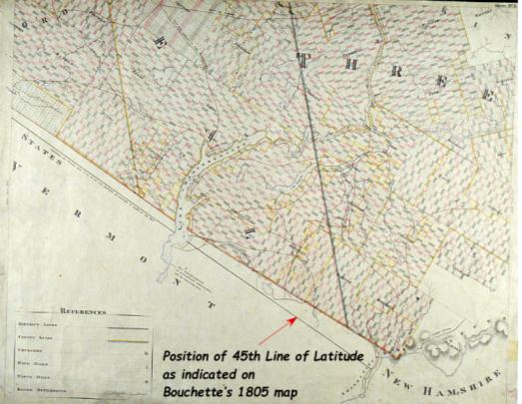
It is not certain when precisely the errors in the survey line first became apparent (i.e. that the surveyed line did not conform to the true 45th line parallel). Following the Constitution Act of 1791, a large number (~ 91) of new townships were created in the wilderness in the southeast part of Lower Canada (Quebec). Under the direction of Surveyor-General Samuel Holland (1764 – 1801) and then Joseph Bouchette (1801 - 1840), deputy-surveyors by the dozens were sent out to demarcate the bounds of these new townships. A number of these deputy-surveyors were quite competent professionals, particularly those with training in military surveying. One can suppose that some of these experienced men, when conducting surveys of the townships bordering the division line, took observations to determine latitude and noted some consistent discrepancies. On Joseph Bouchette’s map printed in 1805, this deviation is prominently displayed, and indicates that the Collins-Vallentine line ran north of the true 45th, and that the magnitude of this error increased towards the east.
A portion of Bouchette’s 1805 map illustrating the Surveyor-General’s understanding of the divergence between the true 45th and the Collins-Vallentine Line.
Rumblings of a significant survey error also reached the ears of the Vermont Legislature. In May of 1806 they dispatched Reverend Samuel Williams of Rutland to make his own determinations of Latitude. The good reverend was apparently subconsciously imbued with the spirit of manifest destiny, for his calculations placed the “true” 45th at the junction with Hall’s Stream, 13¾ miles and 54 rods further north that the Collins-Vallentine line, and at Lake Memphremagog, seven miles and 71 rods further north! Evidently both parties felt quite cheated. This ambiguous situation persisted until the close of the War of 1812 and the signing of the Treaty of Ghent.
It is certainly easy now, to be critical of the Collins-Vallentine line. As we shall see, the survey started in error, and in general things only got worse. It is far from a straight line (see accompanying map) and exhibits at least 30 noticeable inflection points where a bearing was not maintained.
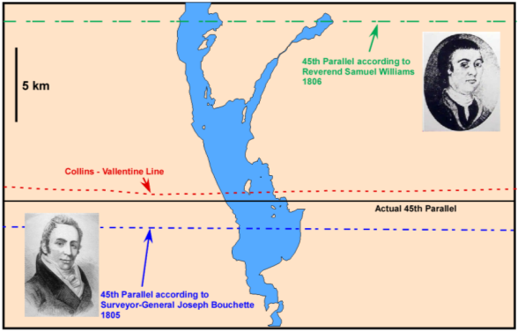
These errors in running the line appear to be quite random, and probably reflect multiple factors. West of Lake Champlain, the line meanders south across the true 45th, then for no apparent reason, back again. Equally, the line on its last westerly leg, like a carrier pigeon nearing its roost, flies straight (but certainly not due West) towards an accurate rendez-vous with the true 45th near St. Regis. How improbable, how fortuitous!
A schematic map of Lake Memphremagog showing the various estimated and actual positions of the 45th parallel.
However a more generous assessment of the line acknowledges that this was an unprecedented wilderness survey of over 160 miles, much of it over mountainous terrain, and undertaken with rudimentary and imprecise surveying instruments. If the eastern portion of the survey is corrected for the initial error in locating a proper fix for the 45th opposite Rouse’s Point, then the line would be seen as being quite conformable to the 45th parallel, and would now be lauded for its accuracy.

1772 Manuscript map drawn by John Collins, Deputy Surveyor-General of Quebec based on the 45th Parallel Survey conducted by John Collins and Thomas Vallentine in 1771 & 1772.
Shown on this and next page.
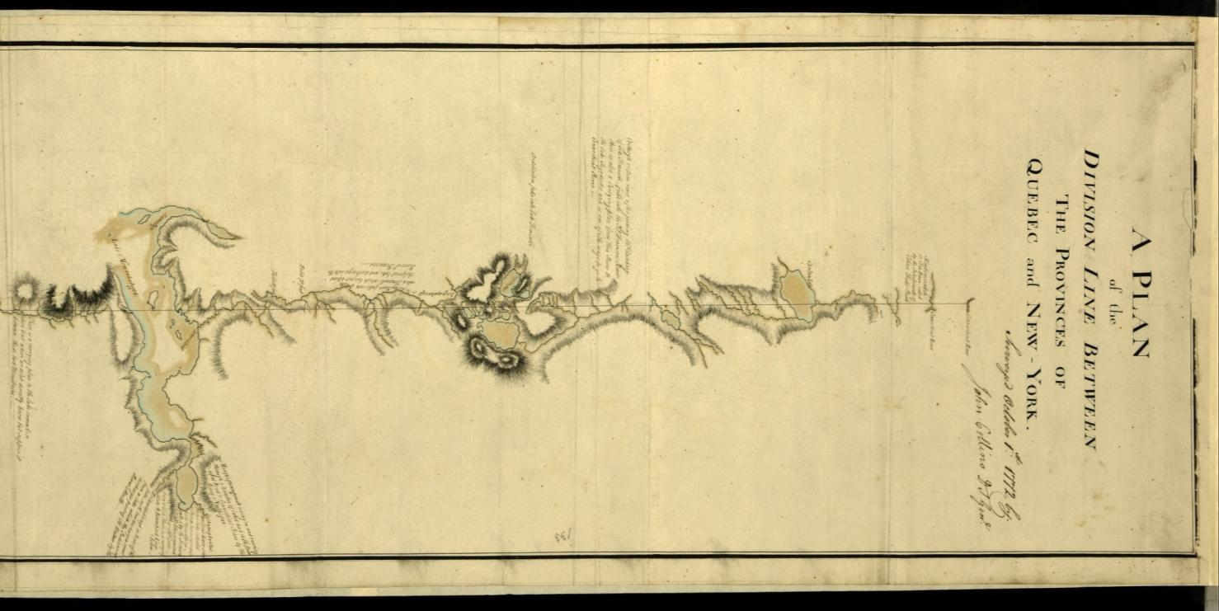

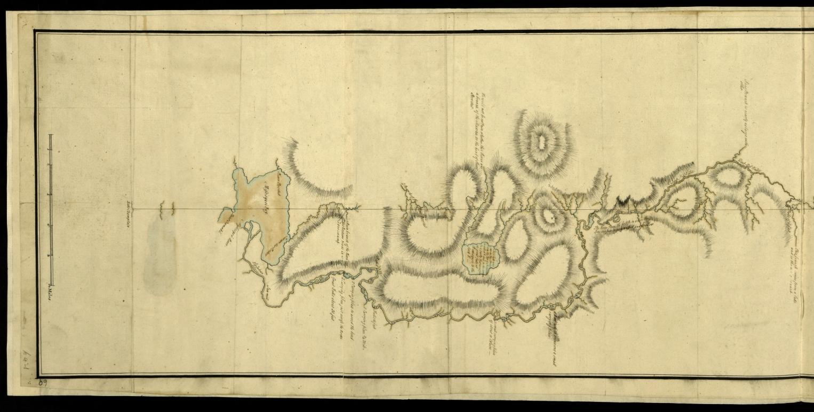
German-speaking astronomers and Fort Blunder
The Treaty of Ghent (1814) returned all boundaries between The USA and British North America to their ante-bellum position and Article 5 of the treaty re-affirmed the 45th Line of Parallel as the border from the St Lawrence River to the headwaters of the Connecticut River. A boundary commission was established by the treaty to work out specific issues and to locate on the ground the international border, which for the most part existed only in the vague language of the Treaty of Paris of 1783. It was initially felt that the 45th parallel would be the least contentious of the issues that the commission was mandated to resolve. Given concerns on both sides about the validity of the Collins-Vallentine line, a re-survey of the 45th N latitude was considered a priority.
For each article of the treaty that involved a mutual boundary, a commission was established with one commissioner (adjudicator) assigned from each side. The commissioners for each section of the border then assembled agents and surveyors to carry out the independent survey work. The agents were responsible for gathering the survey evidence and then presenting the case for selecting a particular boundary. For the British commission looking at article 5, Joseph Bouchette was originally scheduled to survey the 45th, but while organizing this work in Burlington, Vermont in the summer of 1817 he caught Lake Champlain fever (likely malaria) and was brought back to Montreal to recover.
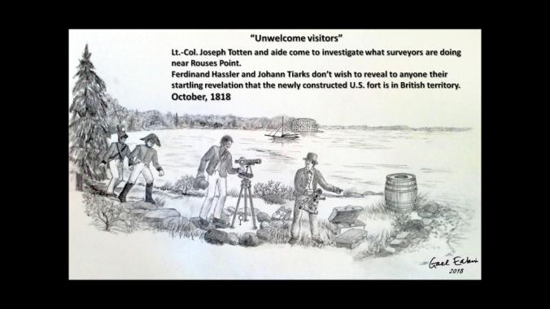
The Americans in any event wished that the survey should start on the St. Lawrence and work its way east, and to this the British acquiesced. In January of 1817 the surveyor David Thompson was sent to St. Regis to determine and fix the 45th latitude for the benefit of the British team looking into article 6, as their westward survey towards the Great Lakes started where the article 5 (45th parallel) survey finished. However the British did not have full confidence in Thompson and instead elected to send an astronomer from Britain to help “fix” the line. That astronomer was German-born, Dr. Johann Ludwig Tiarks who had been working for some time for the eminent scientist Sir Joseph Banks. Tiarks arrived at St Regis in September of 1817, after both Major Ellicott (US surveyor) and Thompson had taken their observations. Ellicott’s observations had placed the 45th within 2 or 3 feet of the spot fixed by Samuel Holland in 1768, whereas Thompson placed it some 1200 feet south. Tiark placed the fix 130 south of Ellicott’s, and the compromise formal fix was placed ½ way between the estimate of Tiark and Ellicott (Thompson’s calculations were ignored). The survey then progressed eastward, working until November when the cold overcast days brought an end to that season of work.

For the survey season of 1818, the Swiss-German mathematician Ferdinand Hassler took over from Ellicott on the American side. He and Tiarks had been acquaintances in England. They trusted each other and worked well together. Work on the survey commenced in early July and by August 4 the teams had worked their way 7 miles to the east of St. Regis. By early October the parties had reached the vicinity of Rouse’s Point on Lake Champlain. When astronomical observations were taken there it was revealed that the Collins-Vallentine line lay north of the true 45th by between 3000 and 3535feet. This was an error far in excess of the expectations of either side. Worse yet, in 1816 the Americans had commenced building an immense octagonal stone fort on the west side of Lake Champlain with 30 foot high walls, intended to dominate passage on the Lake. By 1818 over $275,000 had been spent, a considerably sum in those days, although the fortification was still far from complete. The fort was also well north of the 45th parallel, and so soon became known as “Fort Blunder”. The British were of course, delighted, and insisted that the americans secure the construction site for its “new” owners. German precision was not working in the Americans’ favour and when the elderly and ill Ellicott took over from Hassler the next year, he suggested to Tiarks “we should not do our work so exactingly and forget about completing most of it.”
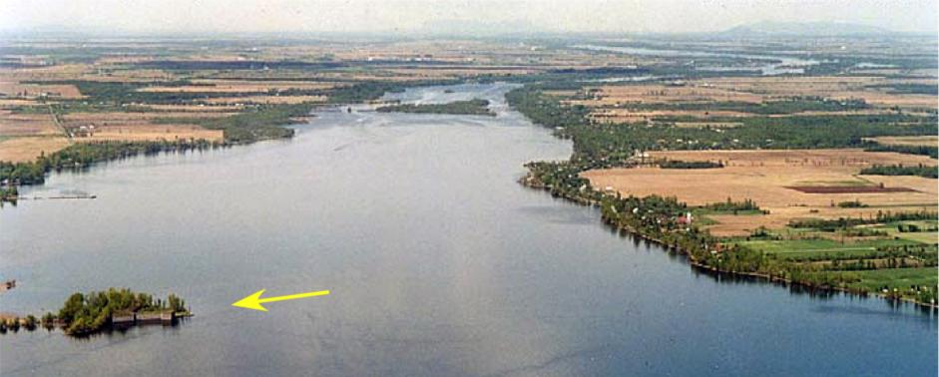
Looking north towards the Richelieu River with ruins of Fort Montgomery (arrow), built on the site of “Fort Blunder”. Next page, a closer view of the ruins of Fort Montgomery below.
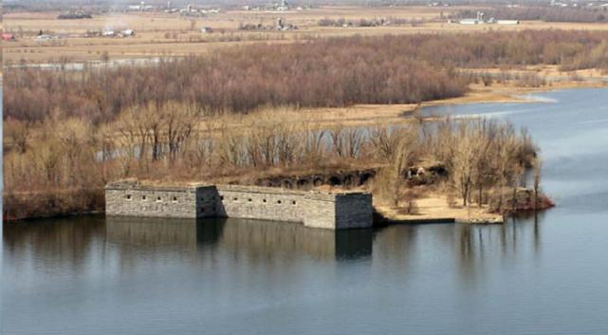
In 1819 the survey didn’t commence until mid-July when Major Ellicott confirmed (within 100 feet) the position of the 45th determined by Tiarks and Hassler on the shores of Lake Champlain. The survey slowly pushed eastward but the assembled team may not have been up to the task. Ellicott sarcastically reported to his wife that “ ... my young men could perform the laborious duty of sleeping 18 hours out of 24, if not interrupted”. Although Tiarks was on hand to take the critical observations, the British survey team was led by William Franklin Odell. Where the survey left off at the close of 1819 is not known.
In 1820 the survey continued along the 45th, but Ellicott’s health took a sharp decline and he died in August while boarding a steamboat to return to the field. At some point in the summer of 1820 the survey reached the headwaters of the Connecticut. With that a far more realistic demarcation of the true 45th parallel now existed on the ground and on the maps of the commission. Overall the British had received better value from their astronomers than had the Americans ........ perhaps even in the political sphere for William Bradley, the American agent, remarked of Tiarks that he possessed “a share of small intrigue uncommon for an astronomer”.
Stalemate and Arbitration: The Dutch Crown Intervenes
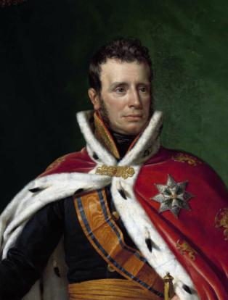
After their respective agents had spent the winter compiling maps and preparing their arguments, the joint British-American commission met, first in May 1821 in New York City and then again in September. Little if any common ground was found, and all the commissioners could do was report their very different conclusions back to their home governments. Direct political negotiations were attempted between 1824 and 1826 but these failed. The only path forward, and one called for by the Treaty of Ghent in the event of an impasse, was arbitration. Sovereigns were the arbiters of choice, and Europe had many to choose from. Finally by early 1829 both parties settled on William 1st of the Netherlands, and he agreed to take on the arbitration role. Extensive submissions were made to the King and he consulted widely with various experts. On January 10th, 1831 the King handed down his award. The award favoured the British with respect to the 45th parallel and the headwaters of the Connecticut, and the Americans with regard to the New Brunswick-Maine boundary. The British, somewhat reluctantly accepted the arbitration, the Americans viewed it as disastrous and the Senate, in June of 1832 rejected it, and asked the administration of President

King Willem I, Kingdom of the Netherlands

Andrew Jackson to reopen negotiations with Britain, but no formal talks began. In late 1835 the British also withdrew their acceptance of the arbitration award.

Prospect of War leads to the Treaty of Washington, 1842
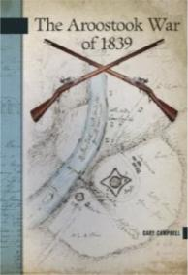
By the early 1840’s a third war between Britain and the USA was becoming a distinct possibility and several crises along the frontier exacerbated existing tensions, including the Aroostook “War” (1838-39) along the New Brunswick-Maine non-border, and American support for Canadian rebels in the 1837-38 Rebellion (the Caroline Incident in 1837 and subsequent McLeod affair 1840-41). Many predicted that conflict was inevitable. Fortunately there were changes of government in both Washington and London, resulting in less hostile attitudes on both sides of the Atlantic. The new US secretary of state Daniel Webster initiated a round of informal talks in 1841 that eventually resulted in the British appointing Alexander Baring (Lord Ashburton) to lead a mission to Washington to see if the deadlock could be broken. Ashburton arrived in the US in April, 1842, but formal negotiations did not commence until June 18th. Commissioners from the State of Maine and Massachusetts were also involved in the discussions, which significantly increased their complexity. A compromise agreement was finally reached on July 22nd. Treaty documents were signed on August 9th, and Ashburton set sail for England in early September.
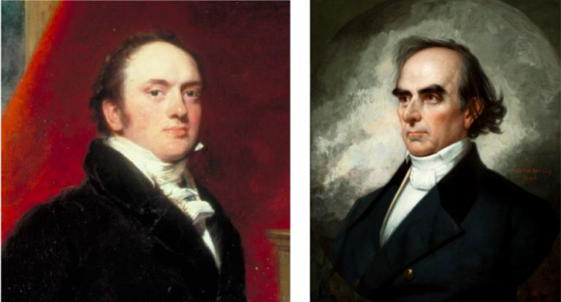
The principal negotiators of the Treaty of Washington, 1842. Lord Ashburton (left) and Daniel Webster (right)
For the Eastern Townships and Northeast Kingdom the significant portions of the treaty concerned the 45th parallel and the headwaters of the Connecticut River. The Collins - Vallentine Line, in all its misplaced and crooked glory , was to stand as the official international boundary, and Hall’s Stream (the westernmost of three possible claimants) was chosen as the official northwest source of the Connecticut River. Although territory was conceded (to New York, Vermont, New Hampshire) by the British, British North America (eventually Canada) gained ground in Quebec and New Brunswick. Ultimately the British acquired more land through the Webster-Ashburton Treaty than had been awarded to them by the King of the Netherlands.
Aftermath
As the politicians and diplomats squabbled for some seventy years, Mother Nature had not sat idly by. What limited clearing had been done along the line in 1772 was either now unblemished forest, or farmers’ fields. The old blazes, if the trees were still standing, were healed over by new bark and the old stone heaps were covered in moss and undergrowth. British and American survey teams were sent out in the spring to summer period of 1845 to try and locate the old line, re-survey it and properly mark its path, which included cutting of a 30 foot swath cleared to chest height (trees to be left where they fell), and an inner 8 foot swath cleared to the ground. Hollow cast iron markers (4-sided obelisks) were manufactured in Boston, and were produced in heights of six and ten feet. The smaller ones weighed about __ lbs each and just getting hundreds of them to the border line was a significant endeavour. These iron monuments were placed at every deflection of the line and wherever the line crossed a lake, river or road. In swampy ground the hollow nature of the markers allowed them to be fitted over cedar posts driven into the ground. On the four sides of the markers were cast the following: side 1 (east) Treaty of Washington, side 2 (south) Albert Smith U.S. Comssr, side 3 (west) Boundary Augst 9th 1842, and side 4 (north) Lt. Col. J.B.B. Estcourt H.B.M. Comssr.
The division of labour between the Brits and Yanks was quite equitable and surprisingly cooperative. At times the teams worked together, at others times separately. The Collins-Vallentine Line was referred to by the surveyors as the West Line, and on the West Line “ the exploration (search for old blazes) was done by the American Commission, and verified by the British. The cutting of the boundary was executed by the Americans alone. The actual survey was made by each Commission, but not acting in company.
The West Line ........... was found to be exceedingly crooked. In marking it the same method was adopted for correcting its deviations as had been resorted to on the North Line, by a succession of straight lines- kept within the cutting of thirty feet. Wherever clearings occurred, the Line was made to run straight across them, from authentic marks on the one side to authentic marks on the other side of the same clearing.”
The official contingent of the British Commission in 1845 consisted of 2 astronomers, 2 surveyors, and 20 men from the Royal Sappers and Miners, all under the leadership of Lieut.-Col. J.B. Bucknell Estcourt, His Majesty’s Britannic Commissioner. Typically these men were distributed into two equally-sized field parties. The number of labourers, mostly axe-men and porters/teamsters, hired by the British Commission ranged up to 500, but in the 1845 survey season the line cutting fell to the Americans, and so the number employed by the British may have fallen to about 50. The numbers on the American side are not currently known.
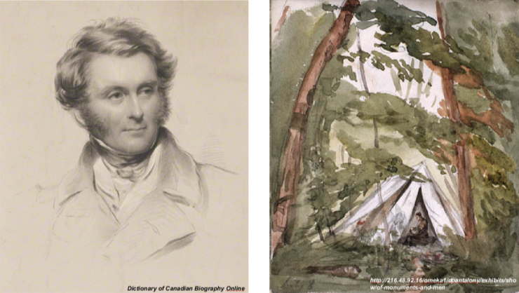
Lieut.-Col. J.B. Bucknell Estcourt, Watercolour sketch of camp life on the survey, by J.B. Estcourt
His Majesty’s Britannic Commissioner

Estcourt was very impressed by the abilities and stamina of the Canadien axe-men, most of whom were hired in the vicinity of Trois Rivieres. Given the immense amount of tree felling done over the course of 3 years cutting the boundary line, Estcourt recorded only 3 serious injuries, and no fatalities. Teams working in the winter through early spring often emerged from the woods with signs of scurvy, and almost certainly illness claimed a number of lives although the number is not recorded.
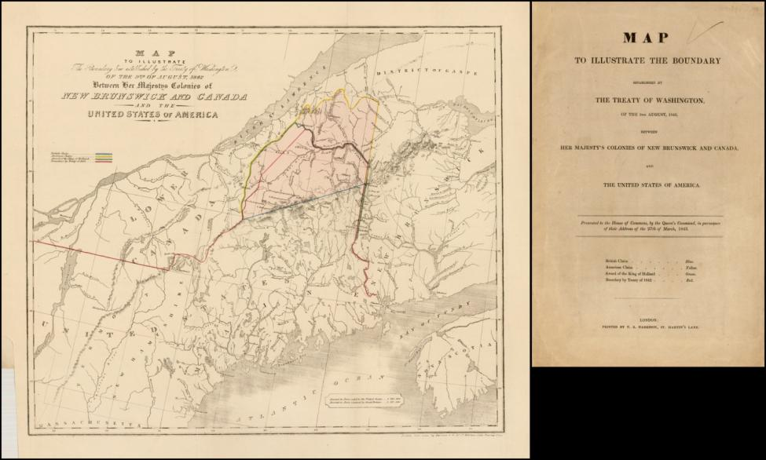
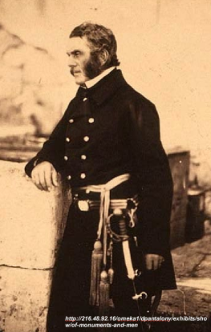
An extremely important requirement of the survey was to provide precise determinations of longitude at 15 select sites along the border, as well as at Montreal and Quebec City. These sites were referred to as Astronomical Stations and a critical one was placed in Ogden. Major (then Captain) William Robinson of the Royal Engineers had been specially trained to do the intricate and precisely-timed astronomical observations (of lunar transits and moon culminating stars) required to calculate longitude. Using gunpowder flashes ignited on the top of Jay’s Peak, simultaneous nighttime astronomical observations were made at Rouse’s Point (Lake Champlain), Richmond, and Lake Memphremagog. Observations were made on nine separate clear evenings between August 1st and September 16th, 1845.
James B. Bucknell Estcourt, later in his career when he was a Lieut.-General in the Crimean War (1853-1856)
The position of the astronomical station in Ogden was near the eastern shore of the Lake some 1017 feet north of the Collins-Vallentine Line, and “….some 345 feet northwest of the barn on Blackader’s farm”. On a nearby, conveniently located sloping ledge of granite, in what was then a meadow (now a wooded area), the survey team inscribed an arbitrary meridian (true north-south) line that indicated the location of the border and the astronomical station. The inscribed stone is still quite legible today (see photo).
In the spring of 1848 a fire destroyed the original notes and uncompleted maps of the American Commission, and duplicates of the British maps had to thenceforth stand in their stead.

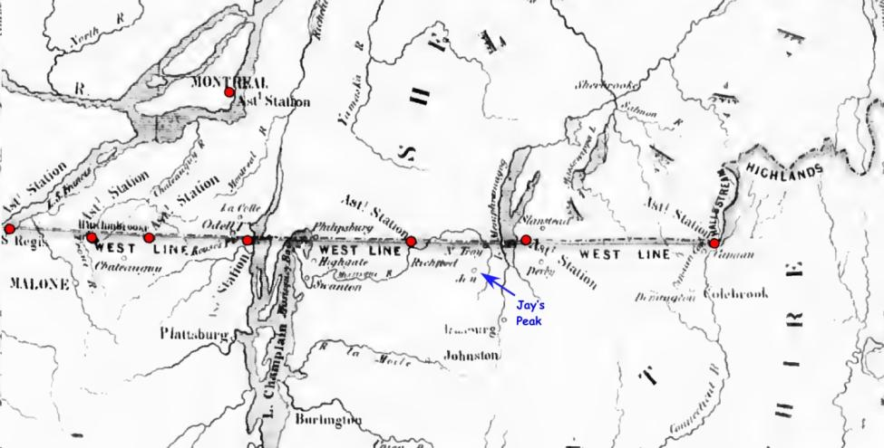
Map of the key astronomical stations for the 1845 Re-Survey.

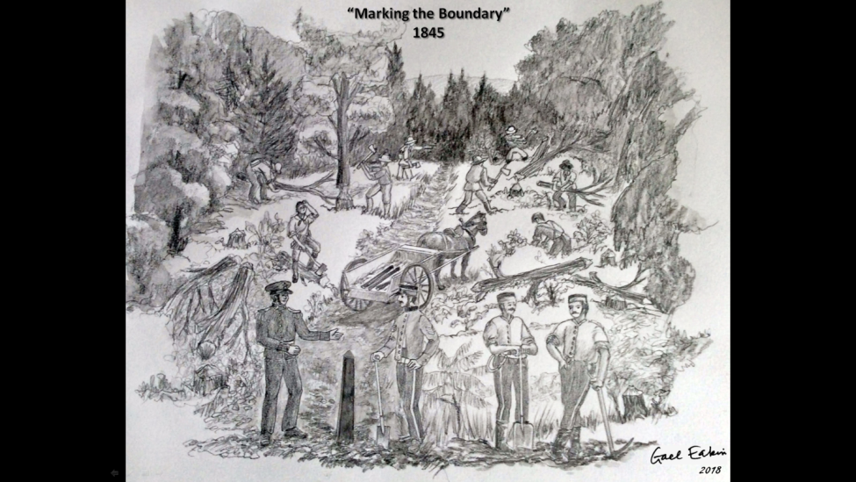
The Americans were responsible for clearing the 45th parallel portion of the boundary, but here they are visited by some Royal Sappers who lend a hand. Sketch by Gael Eakin.
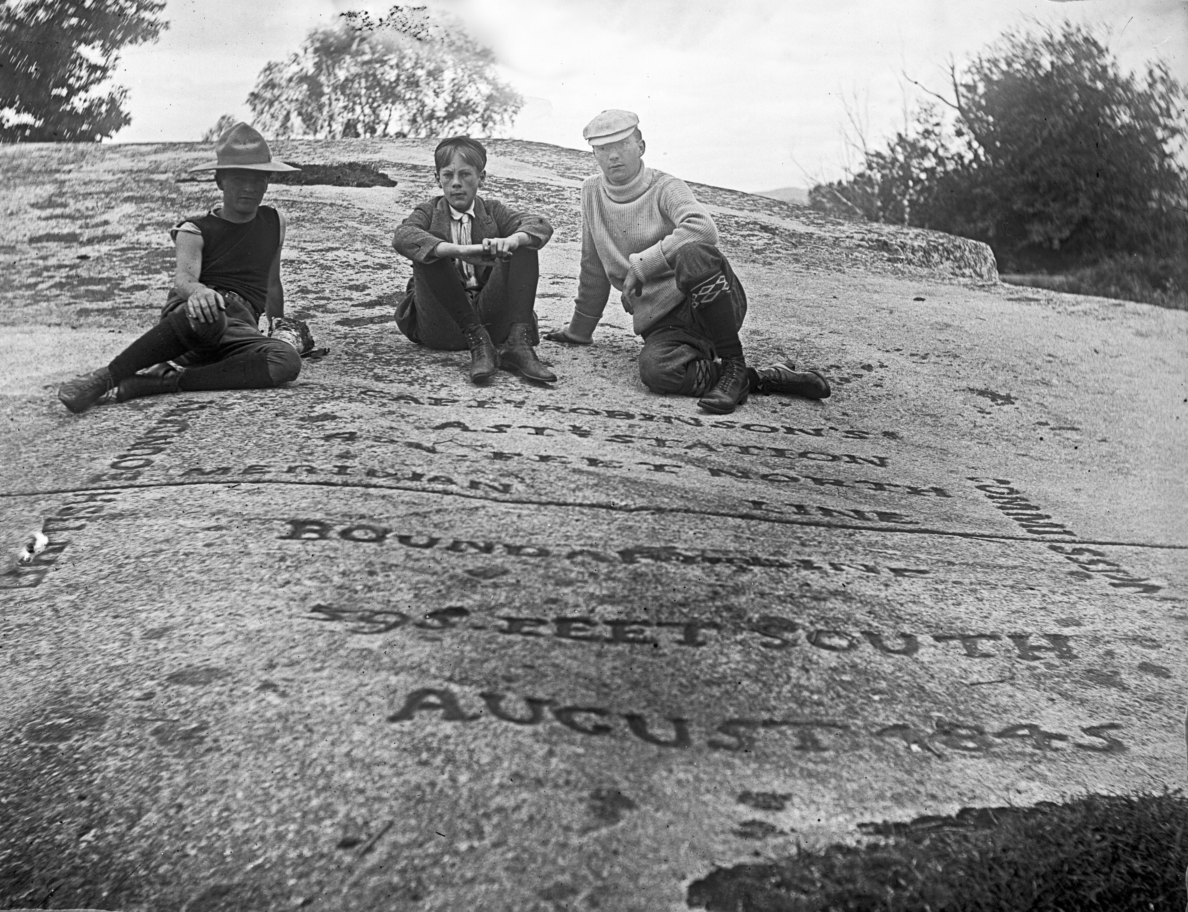
Photograph by Douglas Weir circa 1900 of the engraved rock in Ogden locating the astronomical station used on the 1846 re-survey of the boundary line. From left to right, Frederick Douglas, Ruthven Douglas, and unidentified older boy.
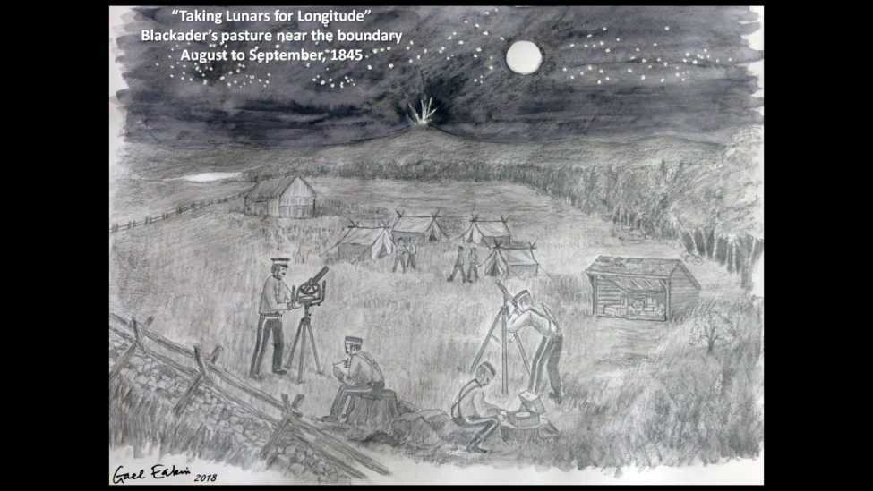
Imagining an historical event. A sketch by Gael Eakin of the astronomical observations on Blackader farm, Ogden as Captain Robinson of the Royal Engineers attempted to get a fix on the longitude of the survey line at a fixed position.

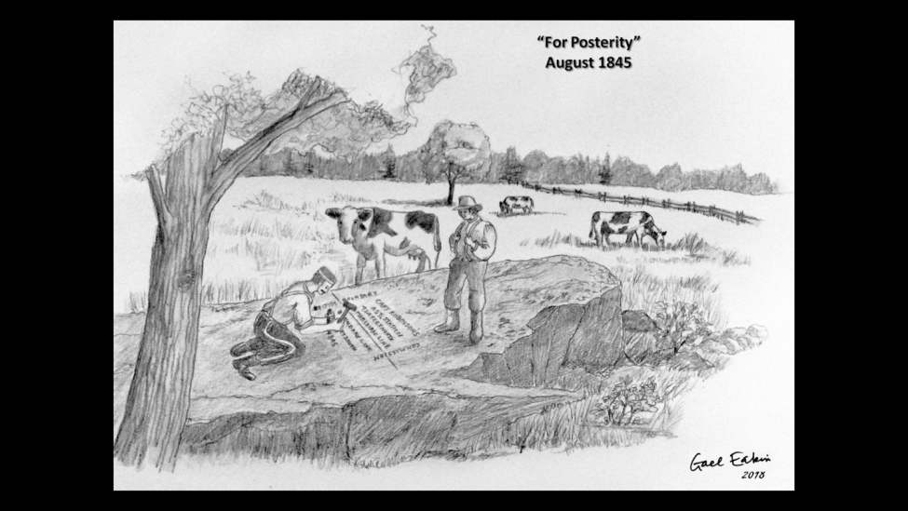
Imagining an historical event. A sketch by Gael Eakin of the engraving of the rock to commemorate the astronomical observations on Blackader farm, Ogden.

From this period to the early twentieth century, the maintenance of the boundary, the cut line and the monuments was at best a haphazard affair. On June 4, 1908, the United States and the United Kingdom (on behalf of Canada) signed a treaty to create the International Boundary Commission. Both countries assigned their own expert geographer or surveyor to serve as Commissioner. Their roles were to accurately define and mark the boundary separating the two countries. In 1925, a second treaty between the United States and Canada was entered into making the International Boundary Commission a permanent organization and empowered the two Commissioners to maintain an effective boundary line, and to determine the location of any point on the boundary line as needed. The Commission comprises both an American and a Canadian Commissioner, and each is responsible for his own budget, equipment, and staff. The responsibility of maintaining the cut swath and the boundary markers is equally distributed to the Canadian and American staff of the two commissioners, and continues to this day.
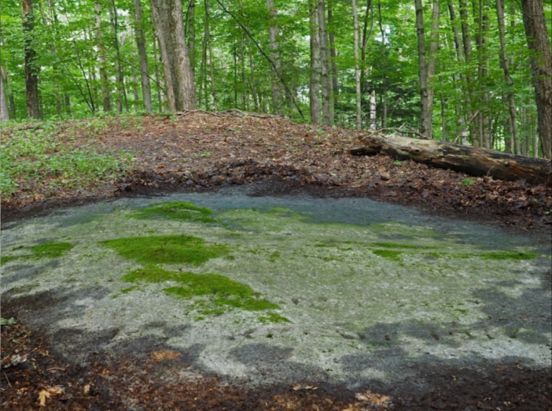
The engraved rock marking the position of the boundary and the astronomical station in Ogden, as it appears today.
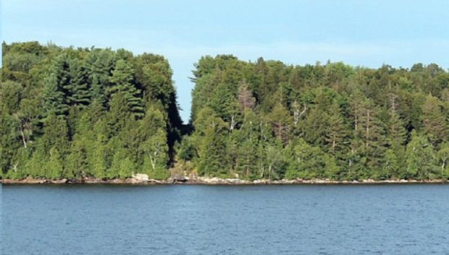

The cut line, (technically it is referred to as the “Vista”) is now 20 feet wide and is maintained by the InternationalBoundary Commission. This is a view from the Lake looking east, with Ogden on the left and Derby on the right.

The Southern Boundary of Ogden
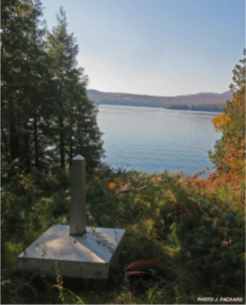
The southern boundary of what is a small, relatively insignificant municipality in Quebec, forms part of an international boundary of great consequence, and of colourful history. Today, for residents of Ogden and Derby, its existence is largely taken for granted, except of course when there are delays at the border crossings. Across the landscape its presence ranges from the obvious to the obscure, depending on whether it cuts across farmers’ fields, village streets, or forested terrain. It is however a line dividing sovereign nations and in today’s climate, for a smuggler, a refugee, an accidental tourist, or someone escaping justice, the illegal crossing of this boundary can result in harsh punishment.
View of cut line along the boundary from the Ogden side, looking west across the Lake.
In former, less vigilant times, a more casual approach to the boundary existed. In the Ogden-Derby area there were at least two uncontrolled crossings (see maps) accessible to wagon or motorized vehicle, and of course there was the Lake itself. Particular during prohibition in the States, all of these routes where utilized to move liquor south.
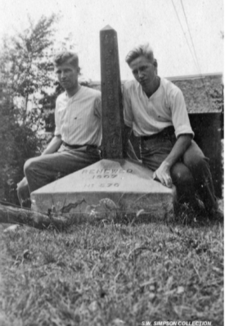
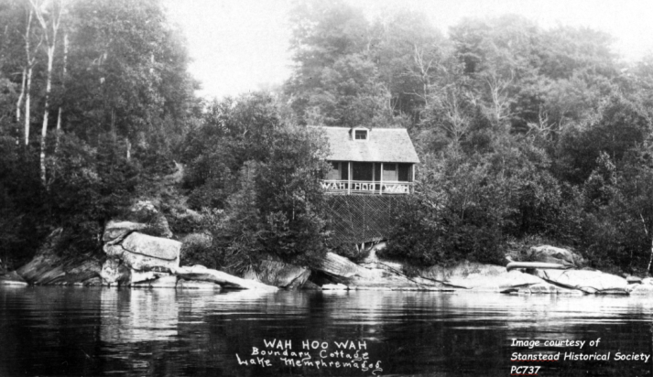
One could own land on either side of the boundary, and ownership of the cut swath was evidently subject to interpretation. In Ogden a golf course once existed close to the Lake and adjacent to the boundary. In the early part of the twentieth century a summer cottage was built almost straddling the border on Lake Memphremagog’s east shore. It was known as the Wah-Hoo-Wah cottage, and was built for Ephraim Smith sometime before 1907. Smith was an alumni of Dartmouth College in New Hampshire, and “Wah-Hoo-Wah”, a pseudo-Indian war whoop, was the college yell. There is some irony in realizing that this cottage, named for an egregious cultural misappropriation, was built on the same spot where the abenaquis had torn down the boundary marker post in 1772.
Wah-Hoo-Wah cottage, just on the American side of the boundary. Ronald Weir (at right) and an unidentified young man sitting on the boundary post just east of Wah-Hoo-Wah cottage (in background), circa 1918.
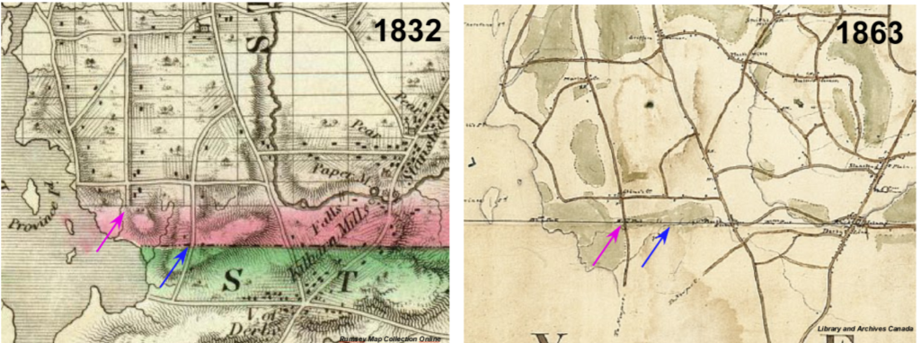
Two maps illustrating that key routes across the boundary have shifted over time. The map on the left by Joseph Bouchette was published in 1832, the one on the right is a military map by C. Whitworth Lloyd, drawn in 1863. It would appear that between these two time periods the major road crossing the boundary in Ogden shifted from a southerly extension of Chemin Beaudoin (blue) to a southerly extension of Marlington at Glyne’s Corner (purple). Neither route crosses the border today.

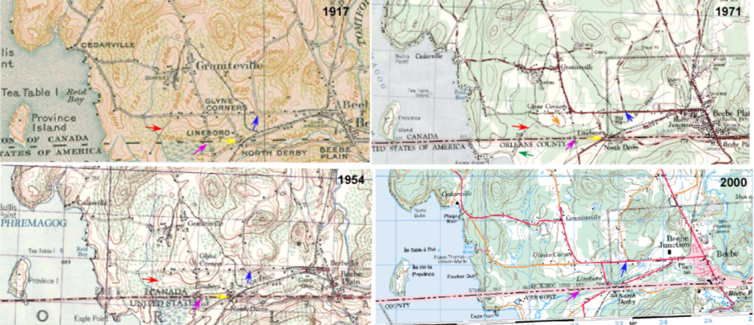
Various trails leading to and crossing the border recorded on more modern maps (red & green). Lineboro crossing shown in yellow. Blue and purple arrows as shown on 1832 and 1863 maps, above.

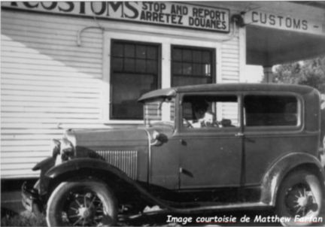
Lineboro Customs, sometime in the 1930’s. Note the extremely young age of the driver!
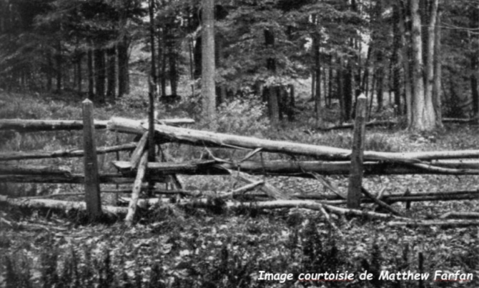
A simple cedar rail fence separating two nations, somewhere in Ogden.

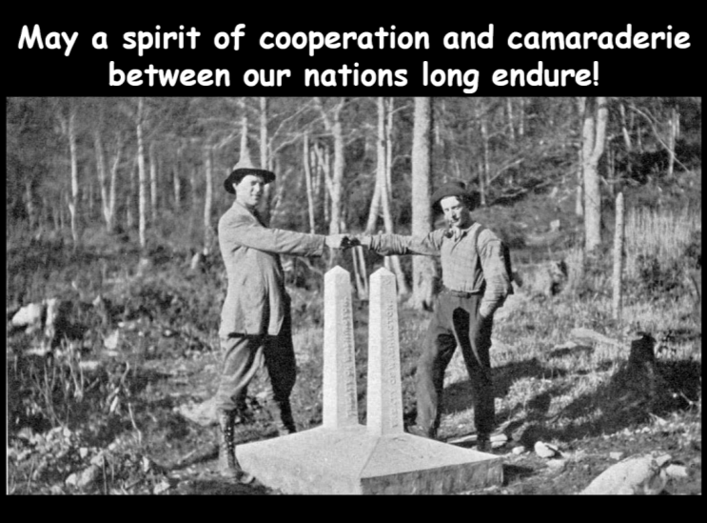
Image courtesy of the Report of the International Boundary Commission, published in 1925.

Not all such boundaries were easily settled. Famously, the east-west extent of New York and New Hampshire (later Vermont) proved intractable. See ________
In truth slight daily to weekly fluxes in the Earth’s magnetic field coupled with local changes in magnetic susceptibility of the rocks nearby, would make such a survey strategy untenable over long distances.
Thomas Vallentine had died in the summer of 1773.
In fact, by the time construction of a new fort on the same site began in 1844, nearly all of the old fort’s stone work had been scavenged by locals.
Hassler resigned due to a salary dispute
The use of the word “War” is rhetorical and ironic. The militias were called out but no combat ensued and no person was killed.
The Treaty of Washington of 1842 is more commonly referred to as the Webster-Ashburton Treaty.
Fortunately, by cutting into some of the old blazes, “there was a scar …. and by counting the rings …it was found that the blazes dated back to 1772-‘3 and ‘4”. By this means the old line was discovered.

